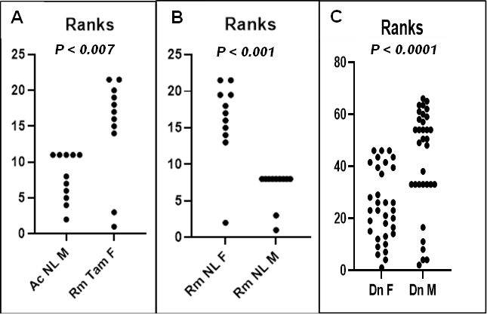
Supplementary Fig. S1. Student´s t test between localities and sexes of white-tailed deer ticks. (A) Bacterial richness (number of OTUs) between Rhipicephalus microplus (Tam F) and A. cajennense (NL M). (B) Comparison between male and female ticks of Rm NL, where females showed a significant difference. (C) Male ticks of Dermacentor nitens, in contrast, showed higher richness than females (GraphPad Software, version 9.5.1). https://www.graphpad.com/quickcalcs/contMenu/). Statistical significance with Student’s t test is cited. (For abbreviations, see Fig. 2).

